**LAPORAN PRAKTIKUM**

**BAHASA INGGRIS**

**PERTEMUAN KE – 3**



**Disusun Oleh :**

**NAMA : TARISA DWI SEPTIA**

**NIM : 205410126**

**JURUSAN : TEKNIK INFORMATIKA**

**JENJANG : S1**

**Sekolah Tinggi Management Informatika Komputer**

**AKAKOM**

**YOGYAKARTA**

**2020**

**MODUL 3  
Daily Activities**

1. **Tujuan**

* Mampu membicarakan tentang kegiatan sehari-hari mereka menggunakan Bahasa Inggris yang baik dan benar.

1. **Praktik**

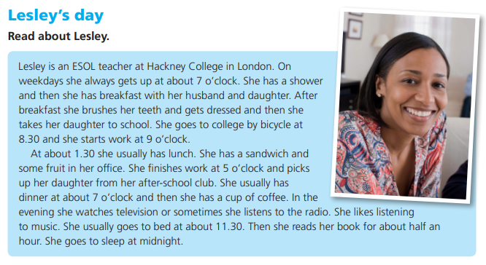Please read the text about Leslie’s Daily routine below.

Choose whether the statement is TRUE or FALSE based on thetext**.**

1. Lesley gets up at seven o’clock. TRUE FALSE

2. She has a shower in the morning. TRUE FALSE

3. She goes to college by bus. TRUE FALSE

4. She picks up her daughter after work. TRUE FALSE

5. She likes listening to music on the radio. TRUE FALSE

6. She goes to bed at eleven o’clock. TRUE FALSE

**Answer the questions.**

7. Who does she have breakfast with? **She has breakfast with her husband and daughter.**

8. How does she go to college? **She goes to collage by bicycle at 8.30**

9. Where does she have lunch? **She has lunch in her office**

10. What does she have for lunch? **She has a sandwich and some fruit.**

1. **Latihan**

Answer the questions about you.

1 What time do you get up? **I wake up at 5 o’clock**

2 When do you usually have a shower in the morning? **After wake up**

3 How do you go to work or college? **I go to collage by motorbike**

4 What time do you start work or college ? **I start my collage at 8 o’clock**

5 Where do you usually have lunch? **At my home, because Covid-19 so I must study at home**

6 What do you have for lunch? **I have lunch with rice and side dishes**

7 What time do you have dinner? **I have dinner at 6 o’clock**

8 Whom do you have dinner with? **Usually I have dinner with family, but sometime I eat dinner alone.**

9 What do you do in the evening? **If I have free time I usually reading book or watch movie on Netflix**

1. hat time do you go to bed? **If I not watch movie I go to bed at 9 o’clock.**
2. **Tugas**
3. 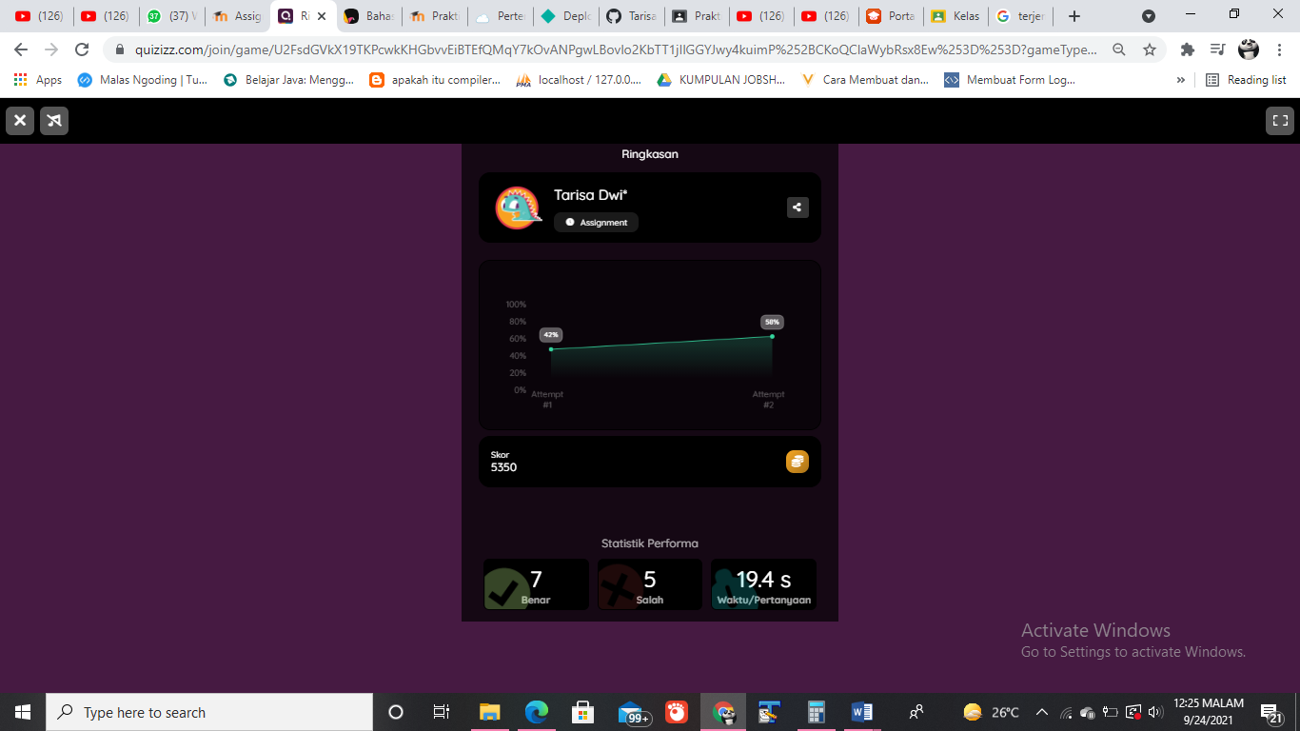Do the quiz in the following link:
4. Write down your daily activity with the following content:

*Hallo guys, my name is Tarisa. I want to tell you about my daily activities.*

*I usually wake up at 5 am in the morning. After that, I take a shower at around 6. I have breakfast with* rice and side dishes *at 7 am. I then go to collage at 8 alone. I go to collage by motorbike.At 12 I have lunch with my friends at the campus canteen. I have chicken noudle soupa and lemon tea.*

*I finish study at 5 o’clock in the afternoon, so I go to home. I usually buy food on the side of the road for me to eat at 9 when watching a movie on Netflix. I have dinner at 7 with my family after that I go to do my night routine.I finally fall asleep at 10 pm at night.*